write a query to display the instructor's last name whose mail ID starts with 'b' from the instructor table.

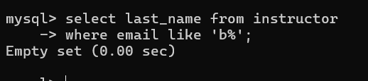

write a query to display the details of the student whose first name ends with the vowels from the student table.

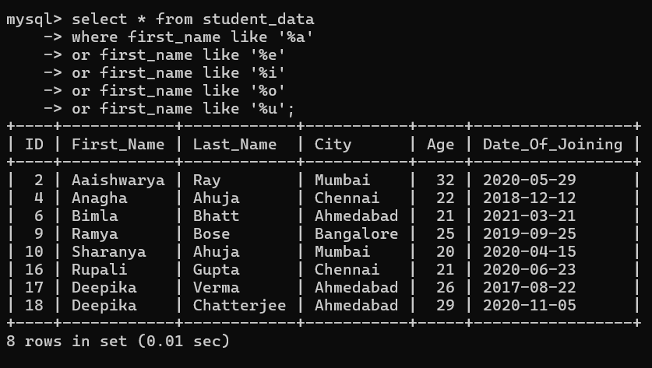

write a query to display the details of the student whose first name contains the vowels from the student table.

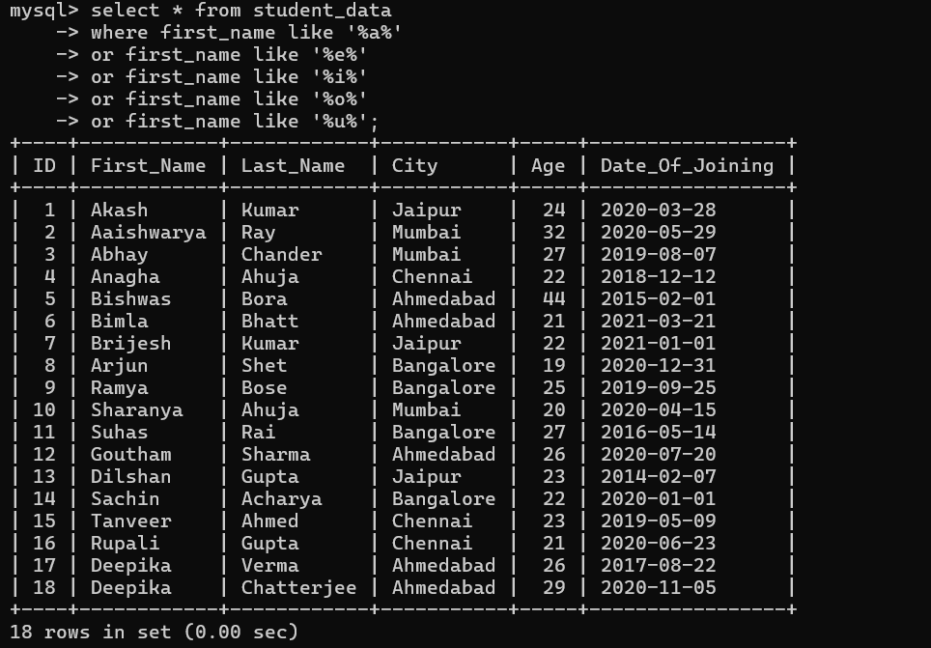

write a query to display the details of the student whose last name ends with the other than vowels from the student table.

